

MBS-910CS | Metal Working Bandsaw

50000341T
400/50/3

PARTS LIST


Walter Meier (Fertigung) AG
Bahnstrasse 24
8603 Schwerzenbach
Switzerland
Phone +41 44 806 47 48
Fax +41 44 806 47 58
jetinfo.eu@waltermeier.com
www.jettools.com

P-50000341T 2013/02/19

Breakdown for the MBS910CS
Transmission Assembly
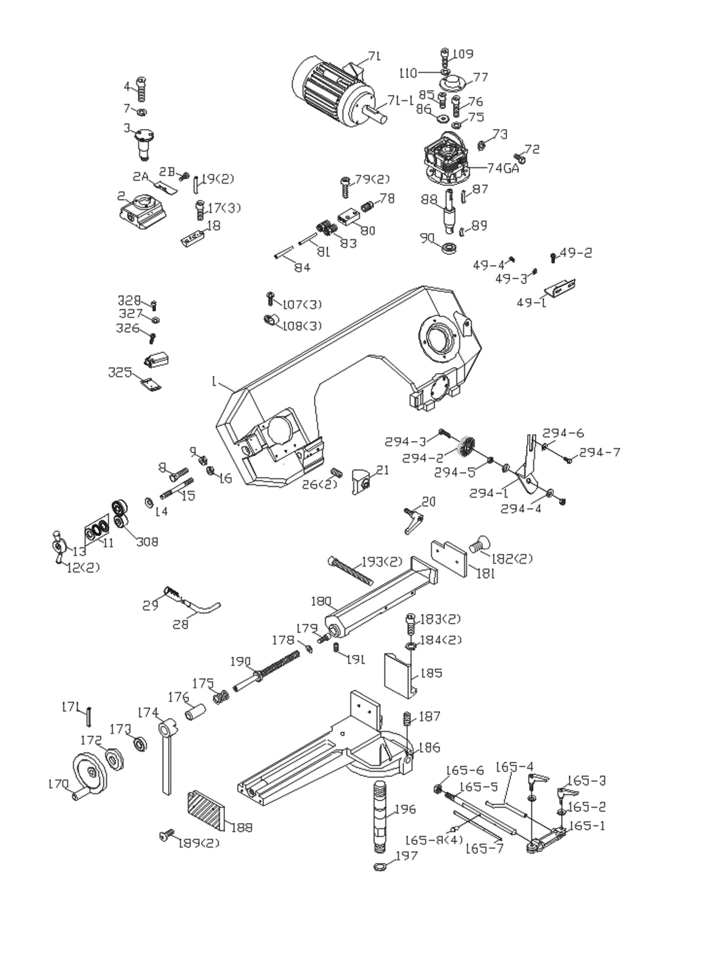

Breakdown for the MBS910CS
Transmission Assembly

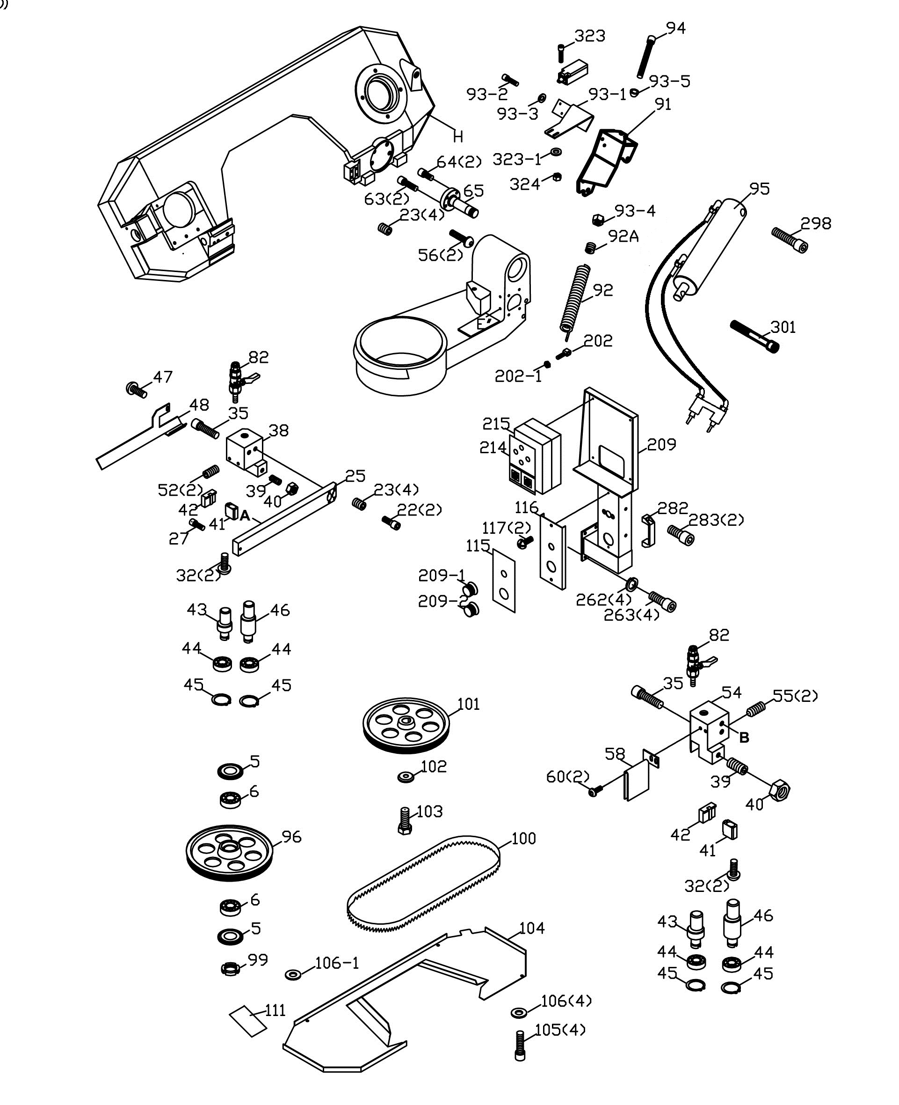

Breakdown for Transmission Assembly

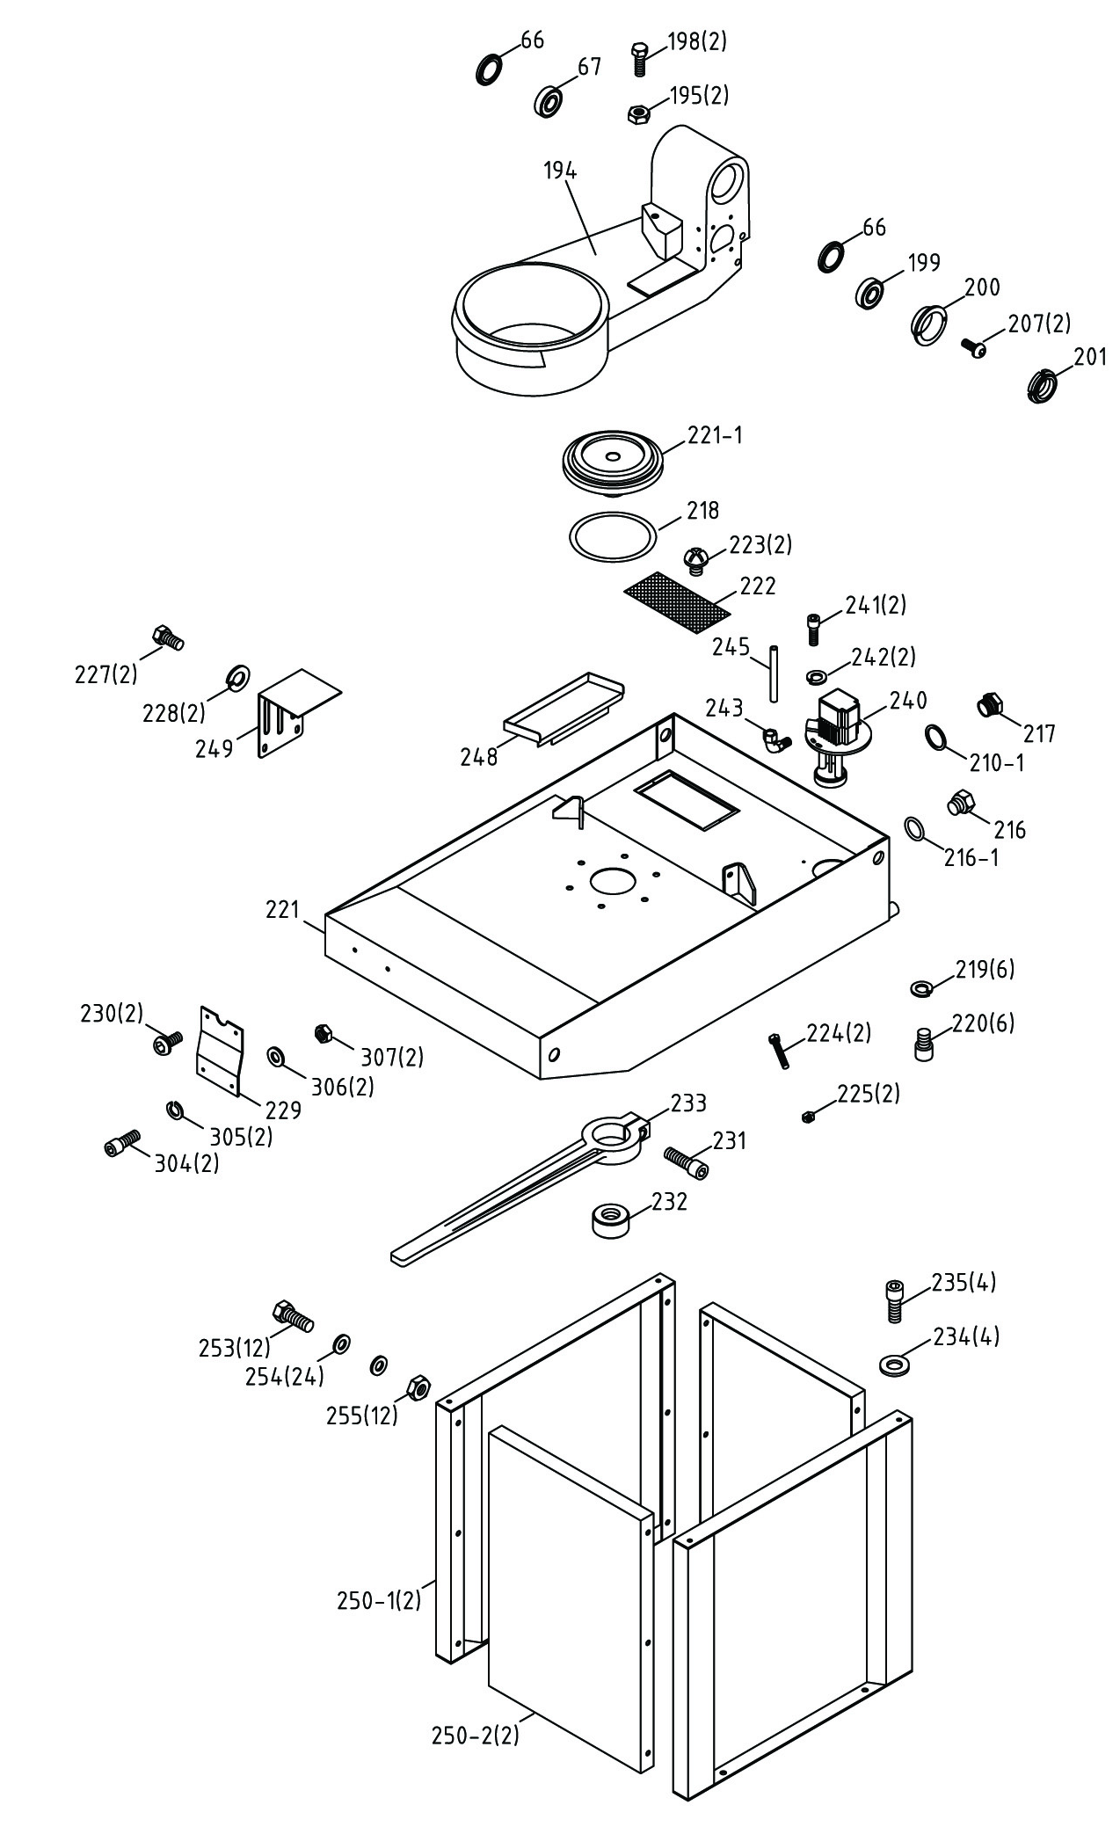
Parts List for the MBS910CS
Transmission & Head Assembly

Index Part
No. No. Description Size Qty.
1 MBS910CS-01 Body Frame 1
2 MBS910CS-02 Anchor Block 1
2A MBS910CS-02A Anchor Plate 1
2B MBS708CS-02B Round Head Screw M5x10 2
3 MBS910CS-03 Shaft 1
4 TS-1504061 Socket Head Cap Screw M8x30 3
5 MBS910CS-05 Anti-Chip Cover 2
6 BB-32006 Tapered Roller Bearing 32006 2
7 TS-2361081 Lock Washer M8 3
8 TS-1490081 Hex. Cap Screw M8x45 1
9 MBS708CS-09 Nut M8 1
11 MBS708CS-11 Thrust Bearing 51203 1
12 MBS708CS-12 Knob 2
13 MBS708CS-13 Blade Tension Handle 1
14 MBS708CS-14 Lock Washer ø16.3xø31.5x1.8t 14
15 MBS910CS-15A Lead screw 1
16 TS-154010 Nut M16 1
17 TS-1504041 Socket Head Cap Screw M8x20 3
18 MBS708CS-18 Fixed Block 1
19 MBS708CS-19 Pin ø 5X40 2
20 MBS910CS-20 Locking Lever M10x60 1
21 MBS910CS-21 Fixed Block 1
22 TS-1504041 Socket Head Cap Screw M8x20 2
23 TS-1503041 Socket Set Screw M6x16 4
25 MBS910CS-25 Blade adjust stick 1
26 TS-1524021 Socket Set Screw M8x10 2
27 TS-1503021 Socket Head Cap Screw M6x10 1
28 MBS708CS-28 Connecting Tube 1
29 MBS708CS-29 Handle 1
30 TS-1550071 Flat Washer M10 1
32 MBS910CS-32 Round Head Screw M6x30 4
35 TS-1503011 Socket Head Cap Screw M6x8 2
38 MBS910CS-38 Blade Adjust 1
39 TS-1524051 Socket Set Screw M8x20 2
40 TS-1540061 Hex. Nut M8 2
41 MBS910CS-41 Guide 2
42 MBS910CS-42 Guide 2
43 MBS910CS-43 Eccentric Guide 2
44 BB-608ZZ Ball Bearing 608ZZ 4
45 MBS708CS-45 C-Retainer Ring ø 8 4
46 MBS910CS-46 Eccentric Guide 2
47 MBS910CS-47 Round Head Screw M6x15 2
48 MBS910CS-48 Blade Cover 1
49S MBS708CS-49S Power Cutting Bracket 1
49-1 MBS708CS-49-1 Power Cutting Bracket 1
49-2 MBS708CS-49-2 Cross Round Head Screw M3x30 2
49-3 TS-1550041 Flat Washer M6 2
49-4 TS-1503031 Socket Head Cap Screw M6x12 2
52 TS-1523011 Socket Set Screw M6x6 2
54 MBS910CS-54 Blade Adjustable 1
55 TS-1523011 Socket Set Screw M6x6 2

Parts List for the MBS910CS
Transmission & Head Assembly
Index Part
No. No. Description Size Qty.

56 TS-1504071 Socket Head Cap Screw M8x35 2
57 TS-1550051 Flat Washer M8 2
58 MBS910CS-58 Blade Cover 1
60 MBS910CS-60 Round Head Screw M5x10 2
63 TS-1505061 Socket Head Cap Screw M10x40 2
64 TS-1505031 Socket Head Cap Screw M10x25 2
65 MBS910CS-65 Frame Pivot Shaft 1
66 MBS910CS-66 Anti-Chip Cover 2
67 BB-32006 Tapered Roller Bearing 32006 1
71 MBS910CS-71AE Motor 1.5HP/400V/3PH 1
72 TS-1503061 Socket Head Cap Screw M6x25 4
73 TS-2361061 Lock Washer M6 4
74GA MBS910CS-74GA Gear Box Assembly (08040509 and higher) 1
75 TS-2361101 Lock Washer M10 4
76 TS-1490041 Hex Cap Screw (08040509 and higher) M8x25 4
77 MBS910CS-77 Reducer Cover 1
78 MBS708CS-78 Hose Fitting ø 8x1/4"PT 1
79 TS-1503041 Socket Head Cap Screw M6x16 2
80 MBS708CS-80 3 Way Valve 1
81 MBS708CS-81 PU Tube ø 6x240L 1
82 MBS708CS-82 Valve 1/8" 2
83 MBS708CS-83 Hose Fitting ø 6x1/8"PT 4
84 MBS910CS-84 PU Tube ø 6x800L 1
85 TS-1505041 Socket Head Cap Screw M10x30 1
86 MBS708CS-86 Private Shaft Washer 1
87 MBS708CS-87 Round Head Key 8x7x50 1
88 MBS910CS-88N Output Shaft (08040509 and higher) 1
89 MBS910CS-89 Round Head Key 8x7x25 1
90 MBS910CS-90 Ball Bearing 6208-2RS 1
91 MBS910CS-91 Spring Bracket (07100404 and higher) 1
92 MBS910CS-92 Spring 1
92A MBS910CS-92A Bushing 1
93-1 MBS910CS-92-1 Down Bracket (07100404 and higher) 1
93-2 TS-1502041 Socket Head Cap Screw M5x16 2
93-3 TS-2361051 Lock Washer M5 2
93-4 TS-1540071 Nut M10 1
93-5 MBS910CS-93-5 Bushing 1
94 MBS910CS-094 Socket Head Cap Screw M10x110 1
95 MBS910CS-95 Hydraulic Cylinder Assembly 1
96 MBS910CS-96 Idler Wheel 1
99 MBS910CS-99 Nut AN06 1
100 MBS910CS-100 Blade 0.9x27x2450x5/8T 1
101 MBS910CS-101 Drive Wheel 1
102 MBS708CS-102 Drive Shaft Washer 1
103 TS-1492021 Hex. Cap Screw M12x30 1
104 MBS910CS-104 Blade Back Cover 1
105 TS-1503041 Socket Head Cap Screw M6x16 4
106 TS-1550041 Flat Washer M6 4
107 MBS910CS-107 Cross Round Head Screw M5x20 3
108 MBS910CS-108 Hose Clip ø 8 3
109 TS-1504031 Socket Head Cap Screw M8x15 2

Parts List for the MBS910CS
Transmission & Head Assembly
Index Part
No. No. Description Size Qty.

110 TS-2361081 Lock Washer M8 2
111 MBS910CS-111 Label For Dimension of Section Cut 1
116 MBS910CS-116 Cover 1
117 MBS910CS-117 Round Head Screw M5x15 2
165S MBS910CS-165S Distance Set Rod Assembly 1
165-1 MBS708CS-165-1 Distance Set Bracket 1
165-2 TS-1550051 Flat Washer M8 2
165-3 MBS708CS-165-3 Knob 2
165-4 MBS708CS-165-4 Stock Stop Rod 1
165-5 MBS910CS-165-5 Distance Set Rod 1
165-6 TS-154009 Hex. Nut M14 1
165-7 MBS708CS-165-7 Scale 1
165-8 MBS708CS-165-8 Rivet ø 2 4
170 MBS910CS-170 Wheel 1
171 MBS708CS-171 Pin ø 5x35 1
172 MBS910CS-172 Bearing Cover 1
173 MBS708CS-173 Thrust Bearing ø 30x ø 47x3.5 1
174 MBS708CS-174 Vises Handle 1
175 MBS708CS-175 Spring 1
176 MBS910CS-176 Bushing 1
178 MBS708CS-178 Washer ø 6.5x ø 18 1
179 TS-1503041 Socket Head Cap Screw M6x16 1
180 MBS910CS-180 Vise Jaw Bracket 1
181 MBS910CS-181 Vise 1
182 MBS708CS-182 Hex. Socket Flat Head Screw M6x12 2
183 TS-1505041 Socket Head Cap Screw M10x30 2
184 TS-2361101 Lock Washer M10 2
185 MBS910CS-185 Vise 1
186 MBS910CS-186 Vise Jaw Bracket 1
187 TS-1524021 Socket Set Screw M8x10 1
188 MBS910CS-188 Vise 1
189 TS-1503041 Socket Head Cap Screw M6x16 2
190 MBS910CS-190 Lead screw Assembly 1
191 TS-1524051 Socket Set Screw M8x20 1
193 MBS910CS-193 Socket Head Cap Screw M6x110 2
194 MBS910CS-194 Swivel Arm 1
195 TS-1540071 Hex. Nut M10 2
196 MBS910CS-196 Vise Jaw Adjustable Rod 1
197 MBS708CS-197 O-Retainer Ring ø 9.8x ø 2.4 1
198 TS-2210451 Hex. Cap Screw M10x45 2
199 BB-32007 Tapered Roller Bearing 32007 1
200 MBS910CS-200 Bushing 1
201 MBS910CS-201 Nut AN-07 1
202 MBS708CS-202 Bolt 1
207 TS-1522051 Socket Set Screw M5x16 2
209 MBS910CS-209 Control Box Base 1
209-1 MBS910CS-209-1 On/Off Valve Knob 1
209-2 MBS910CS-209-2 Throttle Valve Knob 1
210-1 MBS910VS-210-1 O-Retainer Ring P16 1
214 MBS910CS-214 Label for Name Plate (not shown) 1
215 MBS910CS-215 Control Switch Assembly 1
216 MBS708CS-216 Hex Socket Plug 3/8"PT 1

Parts List for the MBS910CS
Transmission & Head Assembly
Index Part
No. No. Description Size Qty.

216-1 MBS708CS-216-1 O-Retainer Ring P14 1
217 MBS910VS-217 Oil Mirror (oil glass) 3/8”PT 1
218 MBS910CS-218 O-Retainer Ring ID19.5x5.7 1
219 TS-2361101 Lock Washer M10 6
220 TS-1505021 Socket Head Cap Screw M10x 20 6
221 MBS910CS-221 Coolant Pan 1
221-1 MBS910CS-221-1 Swivel Arm Base 1
222 MBS708CS-222 Filter 1
223 MBS708CS-223 Cross Round Head Screw M4x8 2
224 TS-1491081 Hex. Cap Screw M10x50 1
224-1 TS-1491161 Hex. Cap Screw M10x100 1
225 TS-1541041 Hex. Nut M10 2
227 TS-1491031 Hex. Cap Screw M10x25 2
228 TS-2361101 Lock Washer M10 2
229 MBS910CS-229 Fixed Plate 1
230 MBS708CS-230 Round Head Screw M6x10 2
231 TS-1505051 Socket Head Cap Screw M10x35 1
232 MBS708CS-232 Nut 1
233 MBS910CS-233 Adjustable Handle 1
234 TS-1550051 Flat Washer M8 4
235 TS-1504051 Socket Head Cap Screw M8x25 4
240 MBS708CS-240E Pump 1/8HP/400V 1
241 MBS708CS-241 Pan Head Screw M6x15 2
242 TS-2361061 Lock Washer M6 2
243 MBS708CS-243 Micro Control Block 3/8"x3/8" 1
245 MBS708CS-245 PU Tube ø 8x1300L 1
248 MBS708CS-248 Fluid Collected Plate 1
249 MBS910CS-249 Feed Support 1
250 MBS910CS-250 Stand Leg Set 1
250-1 MBS910CS-250-1 Stand Leg 2
250-2 MBS910CS-250-2 Stand Leg 2
253 TS-1490031 Hex. Cap Screw M8x20 12
254 TS-1550051 Flat Washer M8 24
255 TS-1540061 Hex. Nut M8 12
262 TS-2361061 Lock Washer M6 4
263 TS-1503041 Socket Head Cap Screw M6x16 4
282 MBS708CS-282 Knob 1
283 TS-1504031 Socket Head Cap Screw M8x16 2
294S MBS910CS-294S Brush Assembly 1
294-1 MBS910CS-294-1 Brush Support 1
294-2 MBS910CS-294-2 Brush 1
294-3 TS-1482061 Hex. Cap Screw M6x30 1
294-4 TS-1550041 Flat Washer M6 2
294-5 TS-1540041 Hex. Nut M6 1
294-7 TS-2246102 Socket Head Button Screw M6x10 2
304 TS-1503041 Socket Head Cap Screw M6x16 2
305 TS-2361061 Lock Washer M6 2
306 TS-1550041 Flat Washer M6 2
307 TS-1540041 Hex. Nut M6 2
308 MBS708CS-308 Blade tension Meter 1
325 MBS910CS-325 Micro Switch Bracket 1

Parts List for the MBS910CS
Transmission & Head Assembly
Index Part
No. No. Description Size Qty.

326 MBS910CS-326 Cross Round Head Screw M4x28 2
327 TS-1550031 Flat Washer M5 2
328 TS-1481041 Hex. Cap Screw M5X16 2

Parts list for MBS-910CS
Breakdown for Gear Box Assembly
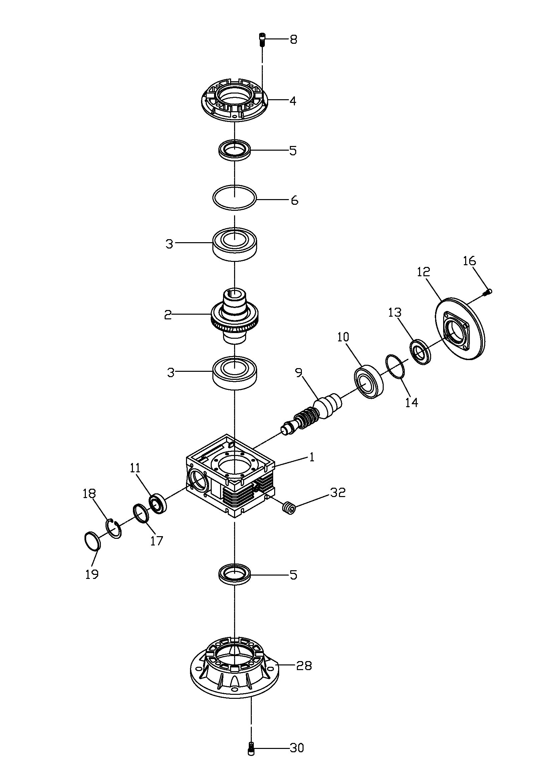

Parts List for MBS-910CS
Gear Box Assembly
Index Part
No. No. Description Size Qty.
1 MBS708CS-74GA-1 Gear Box …1
2 MBS910CS-74GA-2 Worm Gear E=1/40 1
3 BB-6008ZZ Ball Bearing 6008ZZ 2
4 MBS708CS-74GA-4 Gear Box Cover 1
5 MBS708CS-74GA-5 Oil Seal TC40x62x7b 2
6 MBS708CS-74GA-6 Oil Seal 1
8 MBS708CS-74GA-8 Socket Star Head Screw M6x16 8
9 MBS910CS-74GA-9 Worm Shaft 1
10 BB-6006ZZ Ball Bearing 6006ZZ 1
11 BB-6204ZZ Ball Bearing 6204ZZ 1
12 MBS708CS-74GA-12 Motor Flange 1
13 MBS708CS-74GA-13 Oil Seal TC30x47x7b 1
14 MBS708CS-74GA-14 Oil Seal 1
16 MBS708CS-74GA-8 Socket Star Head Screw M6x16 6
17 MBS708CS-74GA-17 Washer 1
18 MBS708CS-74GA-18 C-Ring 1
19 MBS708CS-74GA-19 Oil Seal 1
28 MBS708CS-74GA-28 Connect Flange 1
30 TS-1504031 Socket Head Cap Screw M8x16 4
32 MBS708CS-74GA-32 Oil Plug 2
MBS910CS-74GA Gear Box Assembly 1~32 (08040509 and higher)

Breakdown for the MBS910CS
Electrical Box Assembly
Parts List for the MBS910CS
Electrical Box Assembly

Index Part
No. No. Description Size Qty.

215 MBS708CS-215 Control Box Assembly 1
215-1 MBS708CS-215-1 Magnetic-Contact C-06D 1
215-2 MBS708CS-215-2 Push-Button Switch NPB-F 1
215-3 MBS708CS-215-3 Choice Pole Switch 600V/20A 1
215-4 MBS708CS-215-4 Choice-Switch 600V/20A 1
215-5 MBS708CS-215-5 Emergency-Stop Switch HY57B 1
215-6 MBS708CS-215-6 Power Light NLD-22 1
215-11 MBS708CS-215-11 Box Upper Lib 1
215-12 MBS708CS-215-12 Box Seat 1
215-13 MBS708CS-215-13 Cable-Gland PG-9 4
215-15 MBS708CS-215-15 Cable-Gland PG-13.5 2
215-16 MBS708CS-215-16 Net-Pin 1
215-17 MBS708CS-215-17 Din-Rails 1
215-18 MBS708CS-215-18 Grand Copper Pin 1
215-19 MBS708CS-215-19 Power Cable H07RN-Fx1.5mm² 1
215-20 MBS708CS-215-20 Motor Cable 1.25mm²x7C 1
215-21 MBS708CS-215-21 Limit Cable H05VV-Fx0.75mm² 1
215-22 MBS708CS-215-22 Pump Cable H05VV-Fx0.75mm² 1
215-27 MBS708CS-215-27 Self-tapping Screw M4X8 10
215-28 MBS708CS-215-28 Cross Round Head Screw crew M4X6 4
215-29 MBS708CS-215-29 Cross Round Head Screw M4x12 4
215-30 MBS708CS-215-30 Star Washer M4 6
215-32 MBS708CS-215-32 Limit Switch for Blade Guard AZD-S11 1
215-34 MBS708CS-215-34 Cable-Gland PG-11 2
215-35 MBS708CS-215-35 Limit Cable H05VV-Fx0.75mm² 1
215-36 MBS708CS-215-36 Limit Switch for Bow Down AZD-112 1
215-40 MBS708CS-215-40 Relay 24V 1
215-41 MBS708CS-215-41 Fuse Seat 1
215-42 MBS708CS-215-42 Fuse 2A 1
215-43 MBS708CS-215-43 Fix Block 1
215-44 MBS708CS-215-44 Transformer 400/24V 1
215-45 MBS910CS-215-45 Overload protector 2.4A-3.6A 1

MBS910CS 400/50/3
50000341T
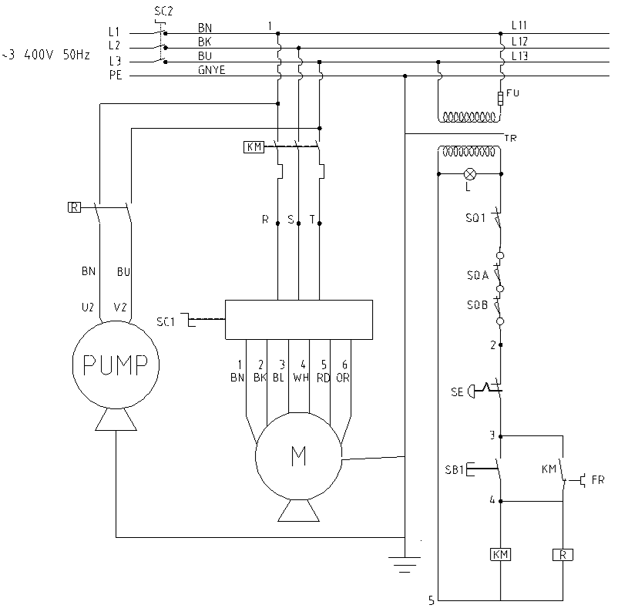

 | colour of strands | Litzenfarben | couleur des cordons
BK | black | schwarz | noir
WH | white | weiß | blanc
BU | blue | blau | bleu
RD | red | rot | rouge
BN | brown | braun | brun
GNYE | green-yellow | grün-gelb | vert-jaune
GN | green | grün | vert

 | meaning of symbol | Bedeutung der Zeichen | interprétation
KM | Magnetic contacter | Hauptschütz | contacteur
FU | fuse | Sicherung | fusible
L | lamp | Anzeigenlampe | lampe d´indication
SE | emergency stop switch | Not-Aus Schalter | arrêt d'urgence
SB1 | start button | Ein-Schalter | bouton marche
SC1 | choice speed switch | Aus-Schalter | bouton arrêt
SC2 | pump switch | Kühlmittel-Schalter | bouton pompe
SQ1 | downer limit switch | Positionsendschalter | micro
M | main motor | Hauptmotor | moteur principal
P | pump | Kühlmittelmotor | moteur pompe
SQA | saw lid limit switch | Positionsendschalter | micro
SQB | tension limit switch | Positionsendschalter | micro

